INCORPORATED 1952 VILLAGE BOARD MEETING
(845) 351-4745 (Voice) THIRD WEDNESDAY OF THE MONTH
(845) 351-2668 (Fax)
Website: tuxedopark-ny.gov

VILLAGE OF TUXEDO PARK
80 LORILLARD ROAD
P.O. BOX 31
TUXEDO PARK, NEW YORK 10987

David C. McFadden
Mayor

VILLAGE BOOTH PROJECT RESOLUTION

NOW, THEREFORE, BE IT RESOLVED AS FOLLOWS:
That this Board acknowledges the results of the Front Gate Survey;
That this Board firmly believes that any physical alteration to our main entrance should be done thoughtfully with careful consideration to all potential consequences;
That this Board approves going forward with the Project, provided the following conditions are satisfied:

D. That an inventory of equipment to be placed or utilized within the Project workplace be compiled (it being understood that additional computer equipment supplemental to that in the Keep is contemplated) and that the Project Mangers confirm to the Board via diagram that such equipment will fit in the Project workplace (it being understood that such layout might not be final) with adequate room for work and safety;

LETTER D RESPONSE

Equipment inventories have been taken in the Keep used for secure traffic control by the Village Police Department have been completed by Village Deputy Clerk Denise Spalthoff.

On the following page please photos of the Keep interior work area.
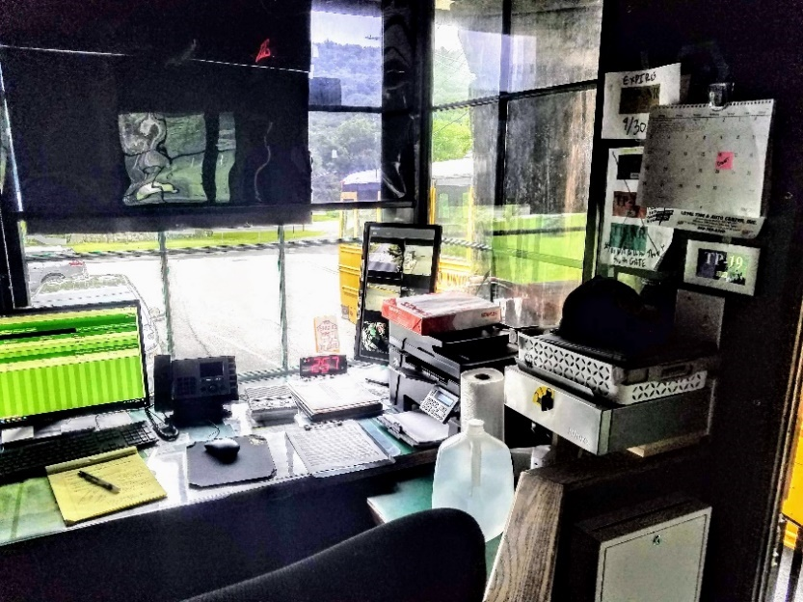
Existing work surface is a mishmash of equipment strewn about and messy. We believe equipment can be consolidated to clear up space.
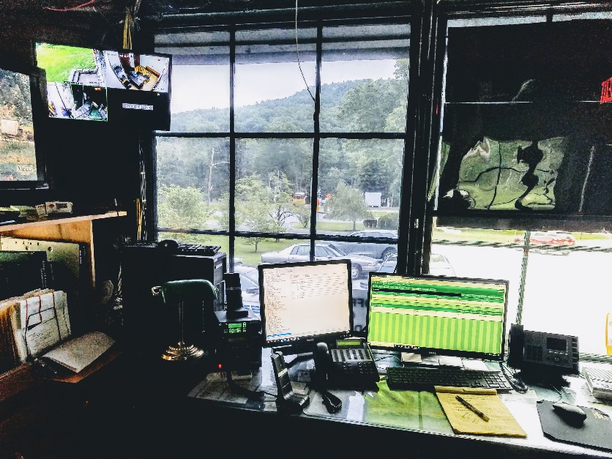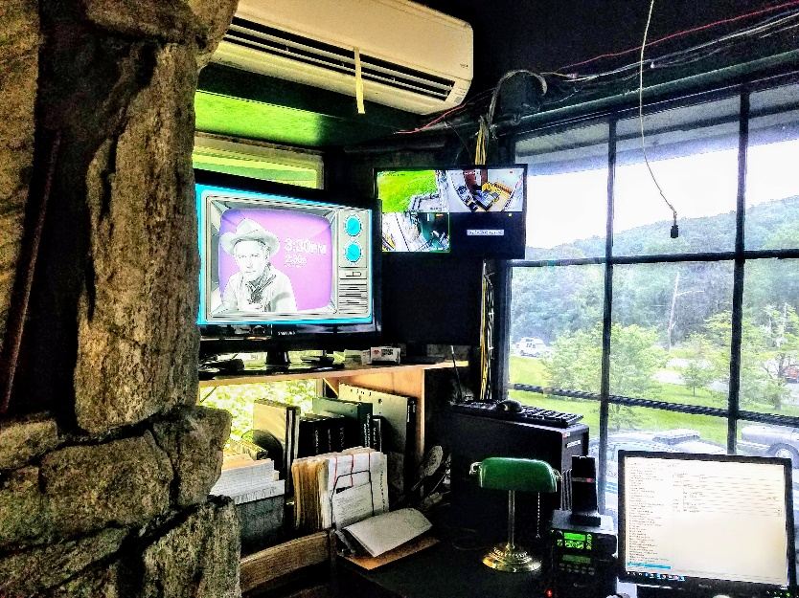
Keep Equipment Existing and Proposed

ITEM | WIDTH | HEIGHT | DEPTH | KEY
911 Computer | 17.5 | 15.75 | 6.5 | 1
Desk Computer | 11.5 | 11.5 | 6.5 | 2
Video Recorder | 16.5 | 17.5 | 1.75 | 3
911 Monitor | 19.75 | 5.75 | 4 | 4
Desk Monitor 1 | 16.25 | 16.5 | 5.5 | 5
Desk Monitor 2 | 21.5 | 16.25 | 7 | 6
Video Rec Monitor | 21.5 | 13.25 | 3.5 | 7
South Gate Monitor | 12.25 | 22.75 | 3.5 | 8
Keyboard 911 | 17.5 | 1 | 5.25 | 9
Keyboard Desk | 17.5 | 1 | 5.25 | 10
Radio | 7 | 8.25 | 8.25 | 11
Microphones (2) | 2.75 | 4 | 6.5 | 12
MG Telephone Operator | 10 | 7.5 | 8.25 | 13
SG Telephone Operator | 10 | 7.5 | 8.25 | 14
Telephone | 8 | 4.75 | 9.5 | 15
Printer | 16.75 | 12.25 | 14.5 | 16
TV | 31.25 | 23.25 | 9.5 | 17
Vertical File Organizer | 11.25 | 8.25 | 12.5 | 18
Vertical File Organizer | 12 | 12 | 8 | 19
Vertical File Organizer | 12.5 | 11 | 4 | 20
Vertical File Organizer | 12 | 12 | 3 | 21
Refrigerator | Standard Under counter |  |  | 22
Microwave | Standard Countertop |  |  | 23
Operator Chair | Standard Office |  |  | 24
Visiting Officer Chair | Standard Office |  |  | 25

Booth Interior Equipment Diagram (Following Page)

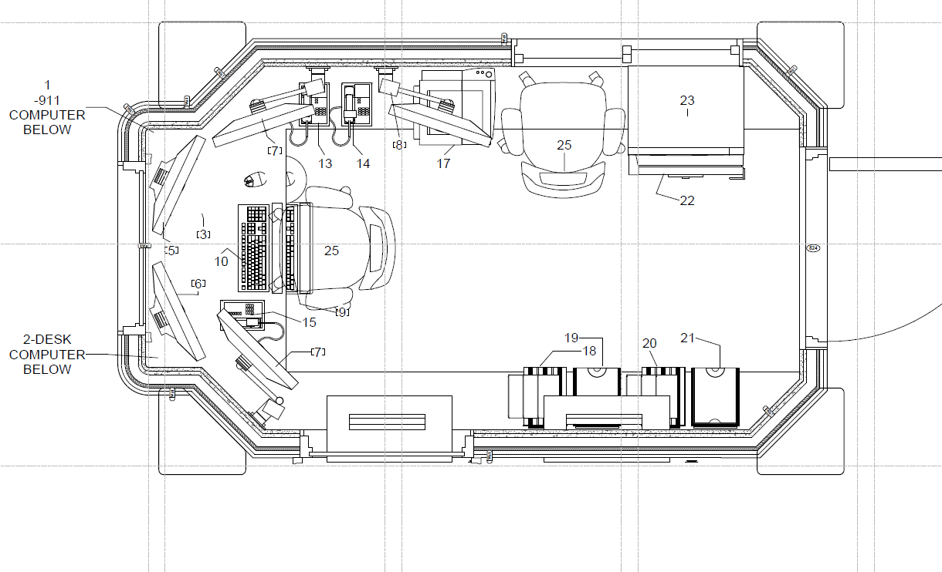
ADDITIONAL INVENTORY

DESKTOP COMPUTERS

Make | Model | Serial # / Service Tag | Location | BUILDING
HP | Compaq 8200 | 2UA1350BF0 | Chief | Police Station
HP |  | 2UA0292G7G | Dep Village Clerk | Police Station
IBM/LENOVO |  | LKNFFX2-88088Z5H | Squad Room | Police Station
HP | Compaq 7800 | 2UA82303F7 | Squad Room | Police Station
HP | Compaq 7900 | MXL9110797 | Squad Room | Police Station
Dell |  | CN0FHW0J71070 | Server Room | Police Station
Dell |  | 9136MN2 | Server Room | Police Station
HP | Compaq 7800 | 2UA81204GM | Sergeant Office | The Keep
HP | 911 | 2UA4470X8Y | Desk | The Keep
Dell | D11S | GTDFMN2 | Desk | The Keep
Dell | D11S | 1K75CP21 | Process Room | The Keep
MONITORS
Make | Model | Serial # / Service Tag | Location | BUILDING
View Sonic | VS15451 | TSP1613A0300 | Chief Office | Police Station
Samsung | 213T/NB21BSAB | NB21H4JY501332J | Dep Village Clerk | Police Station
Dell |  | CN-01K525-47803-2CH-LTW0 | Server Room | Police Station
SCEPTRE | X5G | 424X5G01YH7518 | Server Room | Police Station
Aopen | F50PS | 41300562PV01 | Server Room | Police Station
Acer | AL1913B | ETL3609035451001DBPQ00 | Squad Room | Police Station
View Sonic | VS10040 | P1H040801934 | Squad Room | The Keep
Acer | G226HQL | MMLYLAA001523042938502 | Sergeant Office | The Keep
Acer | V223W | TELC308098003044FA4217 | Desk | The Keep
Dell | CN-OKHONG | QDC00-821-8FRSA05 | Desk | The Keep
HP | OP0900003 | CTDAVAU0C2C6U36R | Desk | The Keep
HP |  | CNC4340339 | Desk | The Keep
AOC (Video Rec) |  | E29G3QA0000089 | Desk | The Keep
Dell | CH-OKONG | 6VZ6VM2 | Process Room | The Keep
Acer (Video Rec) | V173B | ETLE10D0920080FF5E8604 | Property O.C. DA Office | The Keep
LAPTOP (Traffic Counter)
Make | Model | Serial # / Service Tag | Location | BUILDING
HP | 15-9Y065NR | CND7031S6F | Sergeant Office | The Keep
VIDEO RECORDER
Make | Model | Serial # / Service Tag | Location | BUILDING
Cisco |  | FTX 133980JO | Desk | The Keep
Mac/WatchNet | TRB-08EX-2T | 14TRB08EX2T160301052400 | Property O.C. DA Office | The Keep
PRINTERS
Make | Model | Serial # | Location | BUILDING
HP | B3 Q11A | VNB8HD3F09 | Chief Office | Police Station
Brother | MFC-7360N | U62700D2N830664 | Dep Village Clerk | Police Station
HP | B3 Q11A | VNB8HD3F0F | Dep Village Clerk | Police Station
HP | B3 Q11A | VNB8J8L7LG | Sergeant Office | The Keep
Dell | MFC-L2710DW | U64969A8N531072 | Process Room | The Keep
HP | MFP M127FN | CNB9H491XS | Desk | The Keep
Brother | MFC 7860DW | U62702D1N324396 | Squad Room | Police Station
Traffic Counter
Quantity | Make | Model # | Serial # | Location
1 | Jamar Technologies | Radar Recorder | 1706-5132 | Portable
LPR Camera's
Quantity | Make | Model | Serial # | Location
2 | Leonardo | GX450 | LA80230317001005 | Main Gate
1 | Leonardo | GX450 | LA80170605001005 | South Gate
RADAR
Type | Make | Description | Location | BUILDING
Handheld | Genesis | GHD 10625 | Squad Room | Police Station
TELEPHONES
Make | Model | Serial # | Location | BUILDING
Avaya | Partner 18D | A21658518762 | Chief Office | Police Station
Avaya | 18D | 71716064120 | Dep Village Clerk | Police Station
AT&T | ML 17939 | HU601409110 | Dep Village Clerk | Police Station
Avaya | Partner 34D |  | Desk | The Keep
Avaya | Partner 18D | 2A1267645112 | Conference Room/Ext 12 | Police Station
Avaya | Partner 18D | 2A1267644233 | Conference Room/Ext 13 | Police Station
Avaya | Partner 18D | 041647402804 | Locker Room | Police Station
Avaya | Partner 18D | 041649611840 | Squad Room/Ext 10 | Police Station
Avaya | Partner 18D/Lucent | 99SP44105623 | Kitchen/Ext 14 | Police Station
Avaya | Desktop | 08SC02006312 | Kitchen | Police Station
Avaya | Desktop | 025J33301156 | Kitchen | Police Station
Avaya | Partner 18 | 01SP41182284 | Kitchen | Police Station
SHREDDER
Make | Model | Serial # | Location | BUILDING
Royal | HD1400MX | PCUA:89134B-FE | Chief Office | Police Station
Staples | SPL-TXC16HSA | 120101377 | Dep Village Clerk | Police Station
Executive Machines | EPS-1501X | 040688480 | Squad Room | Police Station
FIRE EXTINGUISHERS
Make | Model | Serial # | Location | BUILDING
Badger | 5M B6H | LY 693495 | Desk | The Keep
Badger | 10MB 8H 1999 | RC 160117 | 3rd Floor | The Keep
Badger | 10MB 8H 2004 | WL108554 | Porch | Police Station
Badger | 5MB 6H 2002 | TE 404159 | Kitchen (Pantry) | Police Station
Badger | 5MB 6H | LY 695358 | Kitchen (Pantry) | Police Station
Kidde | PRO10 TCM-3 | NN 138803 | Squad Room | Police Station
Badger |  | WL 718671 | 2nd Floor (Hall) | Police Station
Badger |  | XE 291391 | Unable to locate
Badger | 2.5 SAABC | R999227 | Unable to locate
MEDICAL
Quantity |  |  | Location | BUILDING
1 | First Aid Box |  | Kitchen | Police Station
1 | First Aid Box |  | Break Room | The Keep
TRAFFIC CONES
9 |  |  | Porch | Police Station
2 |  |  | Desk | The Keep
7 |  |  | Roadway
FLASHLIGHTS
3 | Flashlights |  | Squad | Police Station
FLARES
100 | Flares |  | Back Porch | Police Station
RADIO
Quantity | Model # | Brand | Location
1 | 037TNGU984 | Motorola | Squad
1 | 037TNGV352 | Motorola | Squad
1 | 037TNGV341 | Motorola | Squad
1 | 037TNGV349 | Motorola | Squad
2 | PF400 | Motorola w/base chargers | Police Station
1 | 305C26003523 | Scanner | Police Station
1 | UV-5R | Baofeng | Chief Office
1 | Police Radio | Motorola | The Keep
1 | Fire Radio | Motorola | The Keep
4 | Batteries | Motorola | Server Room | Non Function
UNIFORMS
Quantity | Type
46 | Shirt - SS
48 | Shirt - LS
52 | Pants
19 | Cap
12 | Coat
21 | Belt
19 | Shield
19 | Hand Cuff
19 | Cuff Case
19 | Mag Holder
19 | Duty Holster

The equipment inventory is complete and the Booth interior equipment diagram confirms that such equipment will fit in the Project workplace.

